**WEEK 4**

**241001218-SAMYUKTHA SOWMYANARAYANAN**

Q1.

Write a program that accepts the marks in 3 subjects of a student, calculates the average mark of the student and prints the student's grade. If the average mark is greater than or equal to 90, then the grade is 'A'. If the average mark is 80 and between 80 and 90, then the grade is 'B'. If the average mark is 70 and between 70 and 80, then the grade is 'C'. If the average mark is 60 and between 60 and 70, then the grade is 'D'. If the average mark is 50 and between 50 and 60, then the grade is 'E'. If the average mark is less than 50, then the grade is 'F'.

**Input Format:**

Input consists of 3 lines. Each line consists of an integer.

**Output Format:**

Output consists of a single line. Refer sample output for the format.

**Sample Input 1 :**

45  
45  
45  
  
**Sample Output 1 :**

The grade is F

**Sample Input 2:**

91  
95  
100  
  
**Sample Output 2:**

The grade is A

**For example:**

| **Input** | **Result** |
| --- | --- |
| 45  45  45 | The grade is F |
| 91  95  100 | The grade is A |

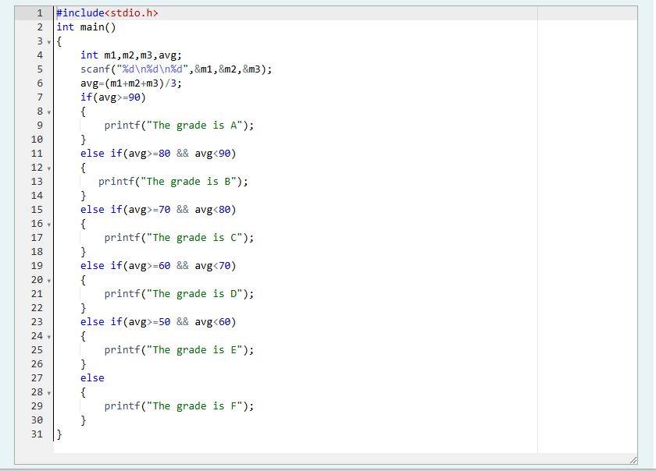

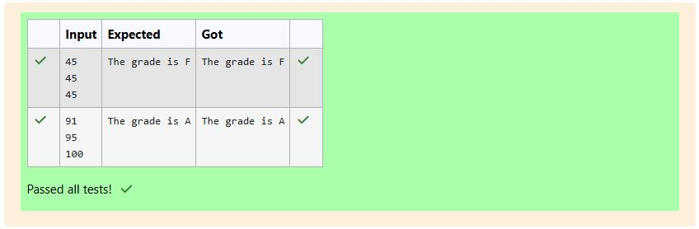

Q2.

Write a program to determine the type of berth when the seat / berth number in the train is given.

**Input Format:**

Input consists of a single integer. Assume that the range of input is between 1 and 72.

**Output Format:**

Output consists of a single string. [Upper or Middle or Lower or Side Lower or Side Upper]

**Sample Input 1:**

9

**Sample Output 1:**

Lower  
  
**Sample Input 2:**

72

**Sample Output 2:**

Side Upper

**For example:**

| **Input** | **Result** |
| --- | --- |
| 9 | Lower |
| 72 | Side Upper |

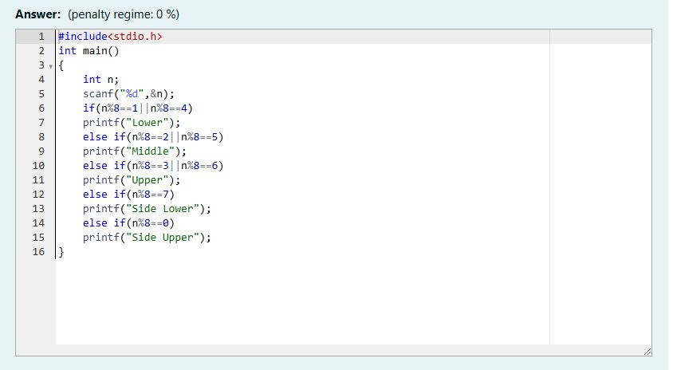

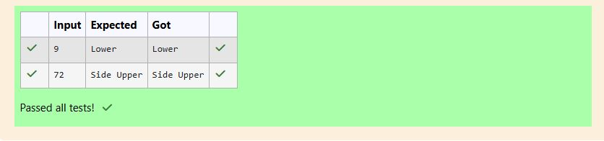

Q3.

Write a C program to simulate a basic [calculator](http://www.rajalakshmicolleges.org/moodle/mod/quiz/view.php?id=85). [+,-,*,/,%]. Use switch statement.

Input Format:

The first line of the input consists of an integer which corresponds to a. The second line of the input consists of a character which corresponds to the operator. The third line of the input consists of an integer which corresponds to b.

Output format:

Output consists of a single line [a op b]. Refer to sample output for details.

Sample Input 1:

3  
+  
5  
  
Sample Output 1:

The sum is 8

Sample Input 2:

7  
-  
6  
  
Sample Output 2:

The difference is 1

Sample Input 3:

4  
*  
3  
  
Sample Output 3:

The product is 12

Sample Input 4:

12  
/  
3  
Sample Output 4:

The quotient is 4

Sample Input 5:

4  
%  
2

Sample Output 5:

The remainder is 0

Sample Input 6:

5  
^  
2

Sample Output 6:

Invalid Input

**For example:**

| **Input** | **Result** |
| --- | --- |
| 3  +  5 | The sum is 8 |
| 7  -  6 | The difference is 1 |
| 4  *  3 | The product is 12 |
| 12  /  3 | The quotient is 4 |
| 4  %  2 | The remainder is 0 |
| 5  ^  2 | Invalid Input |

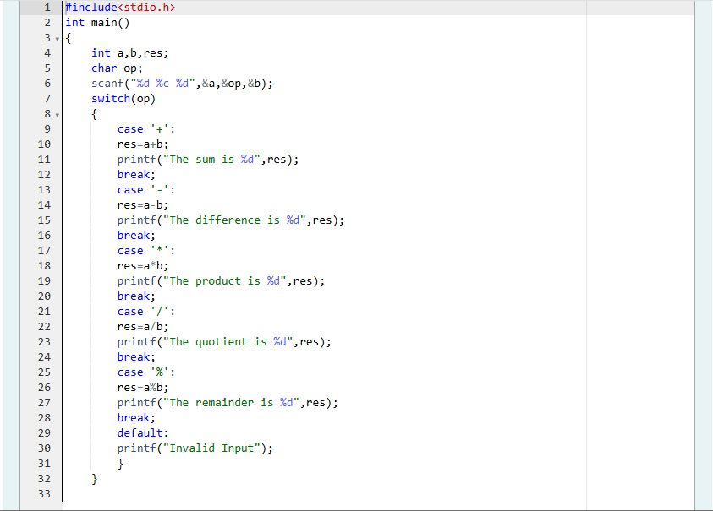

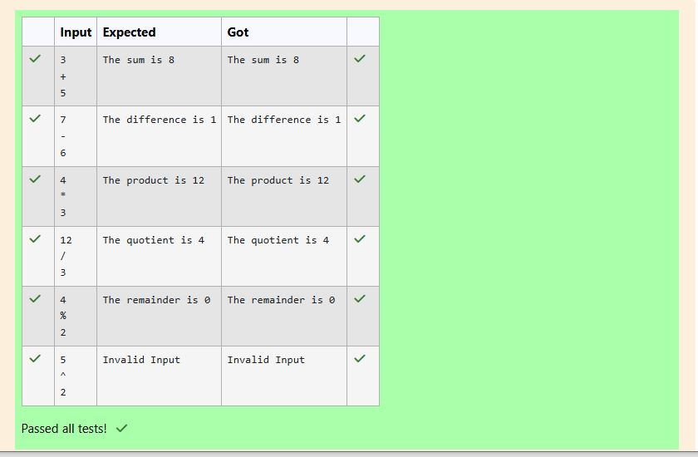

Q4.

In london, every year during dasara there will be a very grand doll show. People try to invent new new dolls of different varieties. The best sold doll's creator will be awarded with cash prize. So people broke their head to create dolls innovatively. Knowing this competition, Mr.Lokpaul tried to create a doll which sings only when a even number is pressed and the number should be not be zero and greater than 100.

So write a program to help Mr.Lokpaul to win.

**Input Format:**

Input Consists of Single Integer which Corresponds to Number pressed by the user to the doll.  
  
**Output Format:**

Display whether the doll will Sing or not. Output consists of the string "Doll will sing" or "Invalid number".

**Sample Input and Output:**

Input

Press a number : 56

Output

Doll will sing

**For example:**

| **Input** | **Result** |
| --- | --- |
| 56 | Doll will sing |
| 55 | Invalid number |

